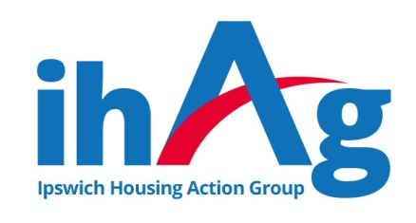
Task Description & Person Specification
ihAg Volunteer – Meaningful Activities

ihAg values the expertise, knowledge and skills volunteers bring to the organisation, and are committed to offering meaningful opportunities for personal and professional development.

The tasks below can be achieved with training, knowledge and confidence, all of which we intend to give you.

Objective of the role:
To support the Meaningful Activities provided to increase self-esteem and confidence of ihAg service users.

Useful Previous Experience:
Work within a support or customer service environment, contact with people who may have low self-esteem, poor mental health and/or unhealthy coping mechanisms

Main Responsibilities:
- Undertake the tasks you are assigned in a timely a manner
- Maintain the highest level of confidentiality in relation to information which is seen/ heard as part of the tasks undertaken
- Work as part of the ihAg team and support other team members.
- Participate in training courses and supervision meetings where appropriate.
- Maintain the health and safety of yourself and others in accordance with current legislation.
- Contribute towards the promotion of equality and diversity.

Responsible to:
Service Manager or other Senior Staff team member – to be confirmed at the commencement of the arrangement.

Commitment to Hours:
We ask that our volunteers commit to one full day, or two half days per week, for a minimum period of six months.

Essential Skills/Knowledge/Abilities:
- Ability to listen and engage with others.
- Ability to use and navigate the internet.
- Ability to prioritise tasks & work on own initiative once trained.
- Keep accurate records.

Essential Personal Attributes:
- Polite, approachable, and empathetic
- Methodical, thorough, and flexible.
- Self-motivated and enthusiastic.
- Willingness to learn.

