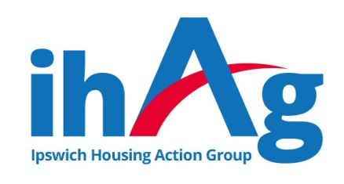
Task Description & Person Specification
ihAg Volunteer - Face to Face

ihAg values the expertise, knowledge and skills volunteers bring to the organisation, and are committed to offering meaningful opportunities for personal and professional development.

The tasks below can be achieved with training, knowledge and confidence, all of which we intend to give you.

Objective of the role:
To support the “face to face” work of ihAg services, by providing support with putting service users at ease, enabling service users to access the internet, preparing refreshments, collecting and collating feedback, and any other tasks as directed.

Useful Previous Experience:
Work within a support or customer service environment, contact with people who may have low self-esteem, poor mental health and/or unhealthy coping mechanisms.

Main Responsibilities:
- Undertake the tasks you are assigned in a timely a manner
- Maintain the highest level of confidentiality in relation to information which is seen/ heard as part of the tasks undertaken
- Work as part of the ihAg team and support other team members.
- Participate in training courses and supervision meetings where appropriate.
- Maintain the health and safety of yourself and others in accordance with current legislation.
- Contribute towards the promotion of equality and diversity.

Responsible to:
Service Manager or Senior Staff member within the team – to be confirmed at commencement of arrangement.

Commitment to Hours:
We ask that our volunteers commit to one full day, or two half days per week, for a minimum period of six months.

Essential Skills/Knowledge/Abilities:
- Ability to listen and engage others.
- Ability to use and navigate the internet
- Ability to prioritise tasks & work on own initiative once trained.
- Keep accurate records.

Essential Personal Attributes:
- Polite, approachable, and empathetic
- Methodical, thorough, and flexible.
- Self-motivated and enthusiastic.
- Willingness to learn.

